CONVERSION AND UNITS
Pearson Edexcel - Wednesday 8 November 2017 - Paper 3 (Calculator) Higher Tier
1.
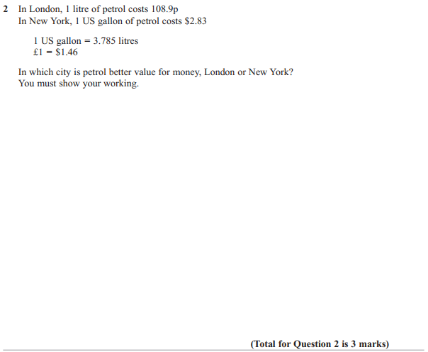

Pearson Edexcel - Friday 6 November 2015 - Paper 2 (Calculator) Higher Tier
2.
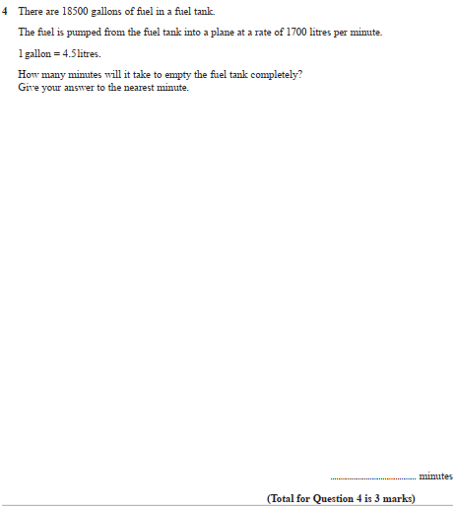
Pearson Edexcel - Friday 6 November 2015 - Paper 2 (Calculator) Higher Tier
3.
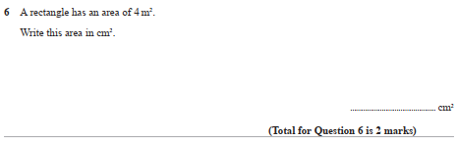

Pearson Edexcel - Thursday 28 February 2013 - Paper 1 (Non-Calculator) Higher Tier
4.
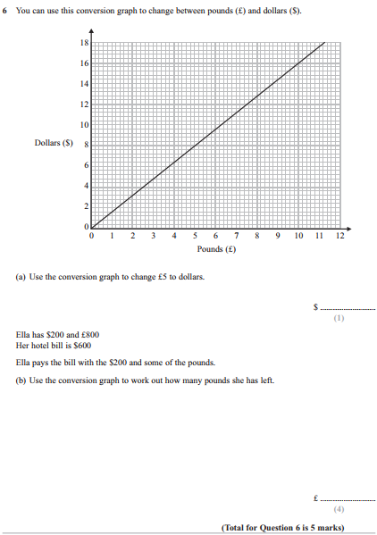

Pearson Edexcel - Monday 14 November 2011 - Paper 4 (Calculator) Higher Tier
5.
Pearson Edexcel - Thursday 5 November 2009 - Paper 3 (Non-Calculator) Higher Tier
6.
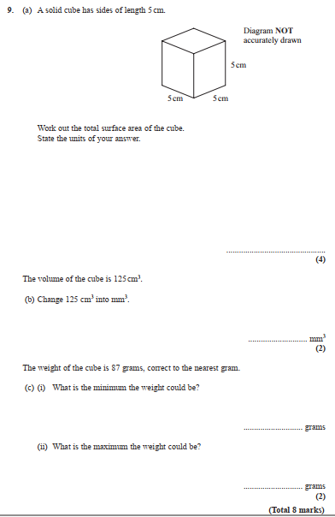

AQA GSCE – Thursday 8 June 2020 – Paper 3 (Calculator) Higher Tier
7.
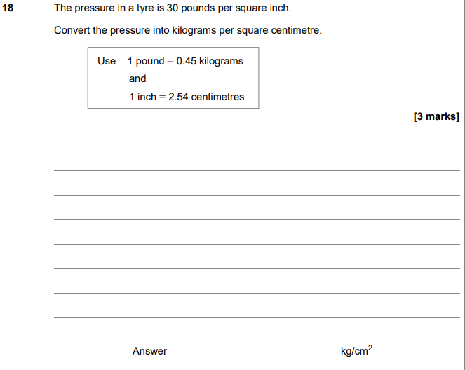

AQA GSCE – Monday 24 May 2018 – Paper 1 (Non - Calculator) Higher Tier
8.
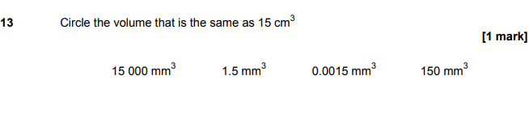

AQA GSCE – Thursday 7 June 2018 – Paper 2 (Calculator) Higher Tier
9.
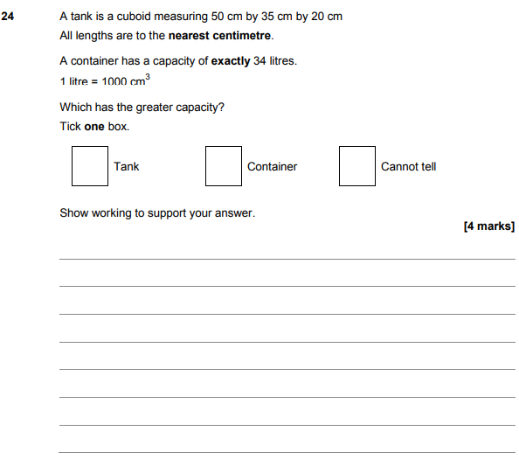

AQA GSCE – Tuesday 12 June 2018 – Paper 3 (Calculator) Higher Tier
10.
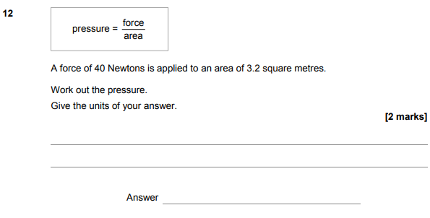
AQA GSCE – Thursday 6 November 2017 – Paper 2 (Calculator) Higher Tier
11.
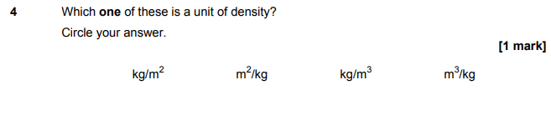
AQA GSCE – Wednesday 25 May 2017 – Paper 1 (Non - Calculator) Higher Tier
12.
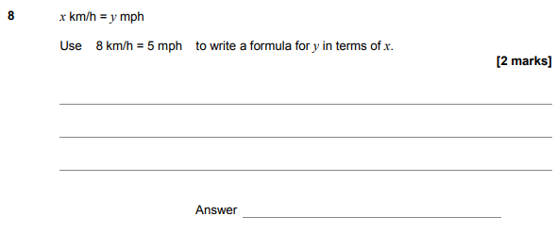
AQA GSCE – Thursday 8 June 2017 – Paper 2 (Calculator) Higher Tier
13.
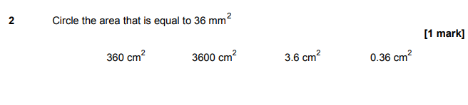
AQA GSCE – Sample Paper 1 (Non - Calculator) Higher Tier
14.
